ELEC 2230 – Tutorial Questions

1. Find the Z matrix of this circuit -

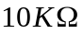
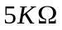

2. Find the Y matrix of this circuit -
R

3. Find the ABCD matrix of this circuit -

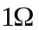

4. Find the ABCD matrix of this circuit -



5. Find the Insertion Loss of this circuit

6.

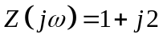



Find 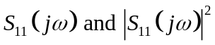

7. Given 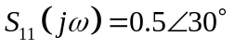

Find 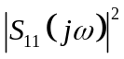 and the Return Loss.

8. A lossless circuit has 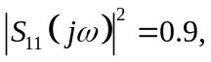 find the Insertion Loss.

9. Write down the S matrix for an ideal, lossless matched transmission line.

10. A bandpass filter has -

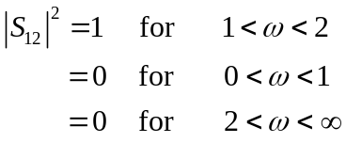

Sketch its frequency response.

